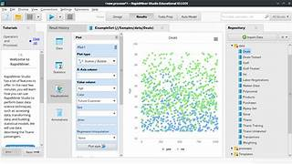

Explore

**RapidMiner** is a powerful **data analytics and AI platform** that caters to both established data analytics teams and those just starting their data journey. [It provides a unified environment for diverse teams to collaboratively generate and share data-driven insights, from building machine learning pipelines to deploying models and extracting valuable information1](https://altair.com/altair-rapidminer).

Here are **five free reference links** where you can learn more about RapidMiner:

1. [**Altair RapidMiner**](https://altair.com/altair-rapidminer): Explore Altair’s official RapidMiner platform, which offers a path to modernization and automation for data analytics teams.
2. [**Introduction to Rapidminer**](https://ace.nus.edu.sg/course/introduction-to-rapidminer/): A course overview from NUS Advanced Computing for Executives (ACE) that introduces you to basic and advanced machine learning in RapidMiner.
3. [**Launch of Altair RapidMiner 2023 Platform**](https://altair.com/newsroom/news-releases/launch-of-altair-rapidminer-2023-platform-delivers-next-generation-generative-ai-capabilities): Discover the latest updates and enhancements to RapidMiner, including generative AI capabilities[2](https://altair.com/newsroom/news-releases/launch-of-altair-rapidminer-2023-platform-delivers-next-generation-generative-ai-capabilities).
4. **RapidMiner Community**: Join the RapidMiner community to access forums, tutorials, and resources shared by fellow users.
5. **RapidMiner Academy**: Enroll in free courses and tutorials offered by RapidMiner Academy to enhance your skills in data analytics and machine learning.

Happy learning! 🚀📊